Introduction
Steganography is the art and science of hiding communication; a steganographic system thus embeds hidden content in unremarkable cover media so as not to arouse an eavesdropper’s suspicion [1]. Unlike cryptography, where the goal is to secure communications from an eavesdropper, steganographic techniques strive to hide the very presence of the message itself from an observer [2]. Image steganography can be broadly classified into spatial domain, transform domain, spread spectrum and model-based steganography [3]. This research focused on the spatial domain technique, where the methods used are the Least Significant Bits (LSB) Substitution and Pixel Value Difference (PVD). Least Significant Bits (LSB) Substitution is the simple method for embedding data by replacing LSB of the randomly selected pixel in a cover image [3]. On the other side, the Pixel Value Difference (PVD) will hide the secret data using the difference between two pixels of non-overlapping blocks [4].
Swain [5] proposed a steganography system, wherein the LSB Substitution and PVD method used to achieve a high capacity of the image steganography system. In this system, the resulted image or stego-image can hide over 105 kB of the secret message, but the Peak Signal-to-Noise Ratio (PSNR) cannot reach more than 42 dB in that amount of data. Contrary to [5], the combination of Modified Substitute Last Digit in Pixel (MSLDIP) and PVD, as well as Mobile Phone Keypad (MPK) Encoding in [6], can achieve PSNR over 46 dB. The PSNR achieved when approximately 66 kB of data hidden in the image. The MPK Encoding is the new technique to encode the message; it can be used to enhance the PVD technique [6]. The method [5] implemented in the RGB image, while the method [6] implemented in the grayscale image. This difference is not a big deal, due to the technique should have a similar result in both RGB image and grayscale image.
In order to increase the hidden message and improve the quality of the stego-image, this research will propose the combined method between PVD and LSB Substitution, as well as a new method of encoding. The LSB Substitution that used in this research is the conventional technique of LSB Substitution, while the PVD method will have a modification since the encoding method is changed. The new method of message encoding will use the concept of the remainder and quotient of the message. The CTR_DRBG is used in LSB Substitution and PVD to enhance the confidentiality of the secret data. In this paper, the proposed method and method from [5] and [6] will be implemented and assessed in the same circumstances. Furthermore, all of the methods will be evaluated against the Triples Analysis from [7] to measure the resistance to the steganalysis technique. As a result, the combination of LSB Substitution and PVD in the proposed method can outperform the previous methods.
The rest of the paper is organized as follows. The Previous Method section discusses the method from [5] and [6]. The proposed method is presented in Sect. 3. The experimental results and discussion are shown in Sect. 4. Finally, the conclusions can be seen in Sect. 5.
Proposed Method
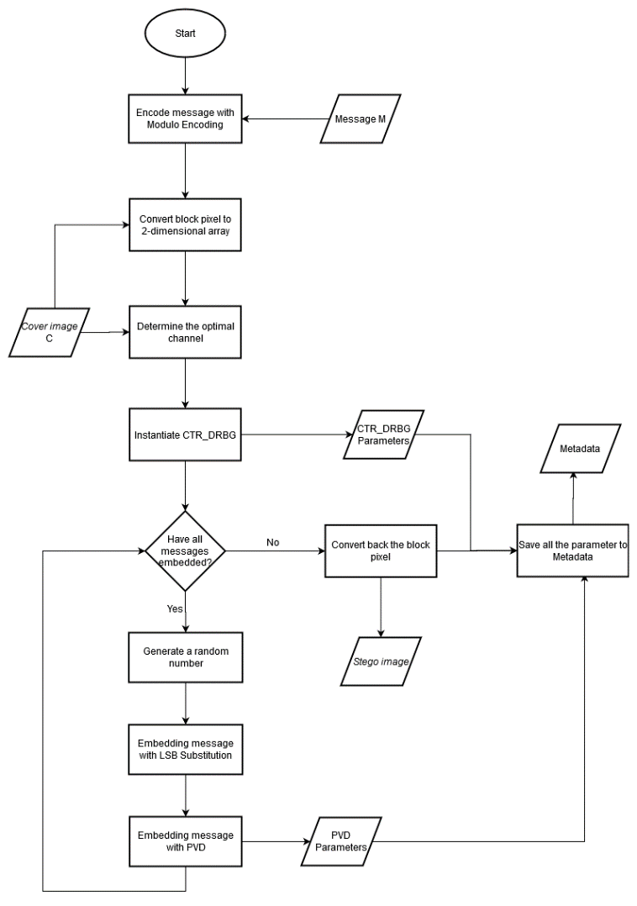
The embedding process follows the flowchart in Figure 3. There are nine main processes in the embedding algorithm. The embedding algorithm categorized into three phases, which are pre-embedding, embedding, and after embedding. In the first phase, the cover image will convert into 2- dimensional array and the byte message will encode with modulo encoding as well as the instantiate CTR_DRBG will be done. In the embedding phase, LSB Substitution and PVD will be used to embed the encoded message, where the random number generated to enhance the confidentiality. In the final step, all of the parameters that resulted from the first phase and second phase will save in the metadata as well as convert back the block pixel to get the stego-image. All of the processes will describe in the subsections below.

- Encode message with Modulo Encoding
The objective of this process is to encode the byte of the message into the modulo encoding format. One single character from the byte of the message will convert into two values. The idea of modulo encoding based on Eq. ()
$$X=q ×n+r$$
X: the single character in byte (digit hexadecimal). X represented as a decimal.
q: the quotient of divide operation X by n.
r: the remainder of modulo operation X by n.
n: the divisor
The two values will represent as rem and div, where the rem value obtained from r and the div value obtained from q. Equation () can be derived into Equation () and Equation () to calculate the rem and div value.
$$\begin{aligned}rem=X Mod n \#\end{aligned} \\ \begin{aligned}div= \left\lfloor X/n\right\rfloor \#\end{aligned}$$
This paper will use 8 as the divisor value. This value used to make more data embedded with LSB Substitution due to the rem value will embed with LSB Substitution, while the div value will embed with PVD. The encoded message saved as a 2-dimensional array.

- Convert block pixel to 2-dimensional array
Block pixel is all of the pixel value of the image, usually represented as a 3-dimensional array. In order to make the embedding process simpler, the block pixel should be converted from a 3-dimensional array into a 2-dimensional array. The block pixel will consist (width x height) rows and three columns, where the width and the height were the sizes of the image. The number columns indicate the RGB channel. The result of this process called cover pixel.

- Determine the optimal channel
The optimal channel means the color channel consist of less the edge value. The edge value is the value at the upper bound and the lower bound of the pixel value. The pixel value has a range between 0 and 255, so the optimal channel is the channel with the minimum amount of 0 and 255. This value will be saved in the metadata due to this information used in the extraction process.

- Instantiate CTR_DRBG
Instantiation CTR_DRBG is the initial process of CTR_DRBG, which in this process, will generate the initial values for V, Key, and reseed counter. The inputs of the instantiation process are entropy input, nonce, and additional input, which all of this input generated by PRNG. The security strength that used is 128 bits since, in the embedding process, the generated random number processed with further algorithms.

The CTR_DRBG is used since it is one of the recommended DBRG by NIST. The block cipher DRBG mechanism specified in the NIST Recommendation has been designed to use any approved block cipher algorithm and may be used by consuming applications requiring various security strengths, providing that the appropriate block cipher algorithm and key length are used, and sufficient entropy is obtained for the seed [800-90A]. The maximum-security strength that can be supported by the DRBG depends on the block cipher and key size used; the security strengths that can be supported by the block ciphers and key sizes are provided in [SP 800-57].

- Generate a random number
At the first time of a random number generated, the initial values that created in instantiation will be used. In this process, the random number and the new parameters produced. The new value of V, K, and reseed counter will use in the next process of random number generation. In this paper, the number of outputs in a single call is 512 bits and reseed after 10,000 calls. All of the boundaries are the recommendation from [349]. The usage of the random number is to enhance the confidentiality of the steganography system. It is also the same idea with [111], where the random number used to ensure the secrecy of the message. The random number labeled with K.

- Embedding message with LSB Substitution
In the embedding process, the cover-pixel grouped into blocks, which in the one block consist of three consecutive pixels, a pixel represented as 24 bits or a pixel consist R, G, and B values. The consecutive pixels labeled P1, Px, and P2. In the LSB Substitution, all of the pixels will be embedded with three different rem values. The rem value represented as three bits of binary form, then each digit of the binary will insert into all channels in the pixel. For instance, the rem value is 5, and then it will represent 1 0 1. Before this message embeds into the LSB of the pixel, it will be processed first to ensure the secrecy of the data. For each pixel in the block, LSB Substitution follows the steps below.
Step 1: Calculate the constant state using Eq. (). It will be used in the next process. This step is part of the process of producing the final random bit.
$$\begin{aligned}constant state=Rotate_Right(\left(R≫2+G≫2+B≫2\right)≪1, K Mod 16)\#\left(\right)\end{aligned}$$

R, G, and B were the red, green, and blue values from the pixel, respectively. Rotate_Right(X, Y) is the function where the bit X right-shifted by Y and the last Y bits put on the left-hand side.

Step 2: Calculate the values PR, PG, and PB using Eq. (), () and (), respectively.
$$\begin{aligned}PR={li}_{Px} XOR K\#\end{aligned}$$
$$\begin{aligned}PG={li}_{px+1} XOR K\#\end{aligned}$$
$$\begin{aligned}PB=\left({li}_{px}{ XOR li}_{px+1}\right)Xor K\#\end{aligned}$$PR, PG, and PB: the constant value for R, G, and B, respectively.
${li}_{px}$: the constant state of current Px
${li}_{px+1}$: the constant state of the next Px (in the next block)
$K$: the random number
If the current block at the last, then the next block will return to the first block.

Step 3: Produce the final random bit for each channel by using Eq. (), () and ().
$$\begin{aligned}AR=The \left({li}_{px} ×K\right) Mod 8-th bit from PR, for LSB of R value\#\left(\right)\end{aligned}$$
$$\begin{aligned}AG=The \left({li}_{px+1} ×K\right) Mod 8-th bit from PG, for LSB of G value\#\left(\right)\end{aligned}$$
$$\begin{aligned}AB=The \left({li}_{px}{×li}_{px+1} ×K\right) Mod 8-th bit from PB, for LSB of B value\#\left(\right)\end{aligned}$$

AR, AG, and AB: the final random bit.
Step 4: Perform XOR operation between the final random bit and binary message in the corresponding channel, then substitute the result into LSB of the pixel.

- Embedding message with PVD
The div message will be embedded with the PVD method, mainly pixel P1 and P2. In this process, the selected channel used to determine which channel will be used to save the message. So, the value of Pi is the value of the targeted pixel on the selected channel. For instance, the targeted pixel is [126, 123, 234], and the selected channel is R, then the value of Pi will be 126. (pixel ordered in RGB order)
The process of the PVD method follows the steps below.

Step 1: Calculate a constant value PA using Eq. (PR)
Step 2: Perform XOR operation between div value and LSB of PA, and labeled with M.
Step 3: Calculate the difference value between Pi and Px using Eq. ()
$$\begin{aligned}d=\left|Px-Pi\right|\#\left(\right)\end{aligned}$$
Pi: The targeted pixel
Step 4: Calculate the difference value between Pi and dl using Eq. ()
$$\begin{aligned}R=d Mod dl\#\left(\right)\end{aligned}$$dl: the lower bound of d. The lower bound calculated with Eq. (6).
$$lower bound= \left\lfloor X / 4\right\rfloor ×4$$
Step 5: Calculate new difference value using Eq. (14)
$$d^{'}= \left\{ \begin{aligned}dl+2\left(R Mod 2\right)+M, if \left\lfloor R/2\right\rfloor =1 \\ du-\left(2\left(R Mod 2\right)+M\right), if \left\lfloor R/2\right\rfloor =0 \end{aligned} ()\right.$$

The result of $\left\lfloor R/2\right\rfloor$ will be saved in the metadata, and this value labeled Q in the extraction process. du is calculated by add dl with 3.
Step 6: Calculate new pixel values using Eq. (15)
$$Pi^{'}= \left\{\begin{aligned}Px-d^{'}, if Px≥Pi \\ Px+d^{'}, if Px<Pi\end{aligned} ()\right.$$
Step 7: Calculate the difference between Pi and Pi’, then change the value of the selected channel with $Pi^{'}$.
Step 8: Check the $Pi^{'}$ whether the value underflow or overflow, if yes, then use Eq. () to handle it. This pixel will have a unique sign and treatment in the extraction process; also, it called outlier pixel.
$$Pi^{'}= \left\{\begin{aligned}\left|Pi^{'}\right|, if Pi^{'}<0 \\ \left(255-Pi^{'}\right)Mod 256, if Pi^{'}>255\end{aligned} ()\right.$$
Step 9: Change the value Pi with $Pi^{'}$.

- Convert back the block pixel
Contrary to the earlier process, this process will convert back the block pixel into the 3-dimensional array as well as the block pixel will save into stego-image.

- Save all the parameters to Metadata
All of the parameters and essential information in the embedding process will save as metadata, which in this process, the data will save as byte. The PVD parameters should convert into a byte since the PVD parameter only has two values, 0 or 1. So, every eight digits of PVD will turn into a byte data. This process will reduce the size of the metadata, rather than all of the data save in text file or directly save into byte without converting.
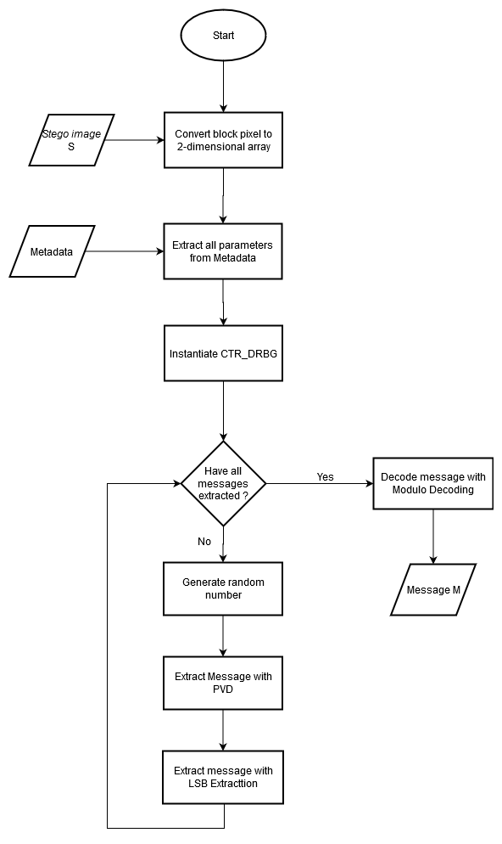
In general, the extraction process will follow the reverse flow of the embedding process. Figure 4 is the flowchart of the extraction algorithms. The extraction algorithm also has three phases, pre-extraction, extraction, and after extraction. In the first phase, all of the parameters will be extracted from the metadata -the optimal channel, PVD parameters, CTR_DRBG parameter, and other important information- also the converting the block pixel, and instantiation CTR_DRBG will be done. In the extraction phase, the hidden data extracted with LSB Extraction and PVD, as well as the generation of random numbers as a part of it. At the final step, the extracted message will decode with modulo decoding to obtain the secret data. The extraction algorithm follows seven main processes below.
- Convert block pixel to 2-dimensional array
This step is similar to the second step in the embedding process but labeled with stego-pixel.

- Extract all parameters from metadata
The metadata will be extracted to get all of the parameters used in the embedding process. The parameter will obtain from the byte of the metadata. It is because in the embedding process, all of the parameters saved as a byte. All of the parameters should extract with the reverse operation in the embedding algorithm.

- Instantiate CTR_DRBG
This process same with the fourth process in the embedding algorithm.

- Generate random number
The generation of the random number will be done as the same process in the embedding process.

- Extract message with PVD
The stego-pixel grouped into blocks, which in the one block consist of three consecutive pixels, a pixel represented as 24 bits or a pixel consist R, G, and B values. The consecutive pixel labeled P1, Px, and P2. The PVD extraction will apply to P1 and P2 since the P1 and P2 embedded with PVD. The objectives of this process are to extract the hidden data and retrieve the old pixel value. The extraction process with PVD follows the steps below.

Step 1: Check whether the pixel is outlier pixel or not. The outlier pixel treated with Eq. () to recover the real value.
$$Pi '= \left\{\begin{aligned}0-Pi^{'}, if Pi^{'}<5 \\ \left(256-Pi^{'}\right)+255, otherwise\#\#\#\#\#\#\end{aligned}\right.$$
Step 1: Calculate the difference value between $Pi^{'}$ and Px using Eq. ().
Step 2: Calculate the difference value between d and dl using Eq. ()
$$\begin{aligned}X= \left\{\begin{aligned}d-dl , if metadata=1 \\ du-d, if metadata=0\#\#\#\#\#\#\end{aligned}\right.\#\left(\right)\end{aligned}$$
X: the value that used to extract message M and recover the Pi.
Step 3: Extract the div value (in decimal form) using Eq. ().
$$\begin{aligned}div=\left(X Mod 2\right)XOR LSB\left({li}_{px} XOR K\right)\#\left(\right)\end{aligned}$$
Step 4: Calculate value R using Eq. () and value Q from metadata.
$$\begin{aligned}R=\frac{\left(X-(X Mod 2\right)}{2}+2×Q\#\left(\right)\end{aligned}$$
Step 5: Recover the Pi before PVD has applied using Eq. ().
$$\begin{aligned}Pi= \left\{\begin{aligned}Px-\left(dl+R\right), if Px>Pi^{'} \\ Px+\left(dl+R\right), if Px≤Pi^{'}\#\#\#\#\#\#\end{aligned}\right.\#\left(\right)\end{aligned}$$
Step 6: Change the value of the selected channel with Pi.

- Extract message with LSB extraction
LSB extraction will extract the hidden message from P1, Px, and P2. The purpose of this process is to retrieve the embedded data from all pixels in the block. The extraction process will follow four main steps bellow.

Step 1: Calculate a constant value PR, PG, and PB using Eq. (), () and (), respectively.
Step 2: Get 3 bits AR, AB, and AG from Eq. (), (), and (), respectively.
Step 3: Perform XOR operation between 3 bits A and LSB of R, G, and B. Arrange the bit result of the XOR operation with RGB sequence, then convert to decimal form. For example, the result from the XOR operation is 1, 0, and 1 (with RGB sequence). The result arranged becomes 101, then 5 is the message rem in decimal form.
Step 4: Save the result as rem value.

- Decode message with modulo decoding
The message from the extraction phase is the encoded message, so the message should be decoded to get the secret data. The encoded data consists of consecutive values of the rem and div value from the byte message. The retrieved process of the byte is done by applying the Eq. () to the encoded message, then represent the result as hexadecimal.

Experiment
The proposed method is implemented on over 131 RGB images in three different sizes from the USC-SIPI Image Database and Caltech Computational Vision Archive. The three sizes were 256 x 256, 512 x 512, and 1024 x 1024. The number of images over the three different sizes is 8 images, 116 images, and 7 images, respectively. All images from Caltech Computational Vision Archive cropped in random position but with size 512 x 512, then saved in PNG format, while there is no preprocessing in the images from the USC-SIPI Image Database and the images saved in TIFF format. All images embedded with ten different messages in text format. Size of the message generated from 23000 to 230000 bits in image 256 x 256, 95000 to 950000 bits in image 512 x512 and 384000 to 3840000 bits in image 1024 x 1024. All of the messages generated with constant increment. The method from research [5] and [6] will evaluate in the same condition with the Proposed Method. The experiment will run on a mobile computer with CPU Intel Core i7-8565U and RAM 16 GB. All of the algorithms implemented with python version 3.7.3 and use the atom as the text editor.
Analysis

The result of the experiment shown that the maximum PSNR from the proposed method, the first previous method and second previous method 2 were 60.66 dB, 53.82 dB, and 54.73, respectively. As a comparison, the minimum PSNR was 46.01 dB, 33.71 dB and 42.28 dB. This result obtained from the explained experiment before. As can be seen, the proposed method outperformed in PSNR value over two previous algorithms. It also represented in Table 1, which is the figure shown the minimum and maximum of PSNR from three different methods. This table shows the three highest and lowest PSNR over three different sizes of the image. Contrary to the high value of PSNR, the proposed method has a longer execution time than the others. It can happen since the proposed method uses the CTR_DRBG as a part of the system, which it has AES computation inside it.
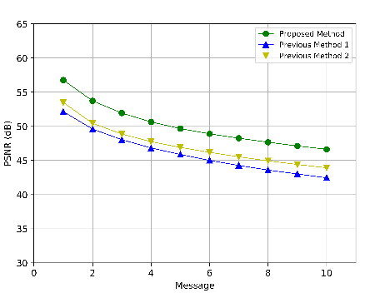 | 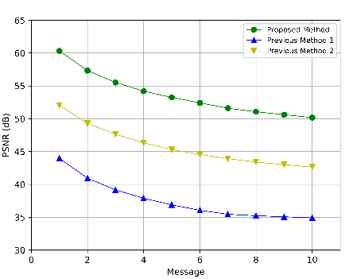 | 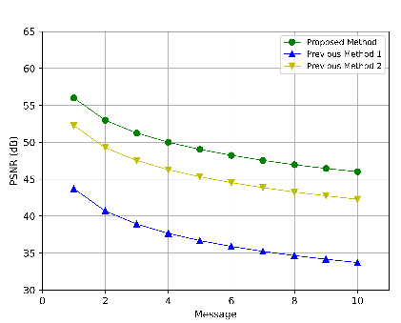
Image 3 | Image 92 | Image 17

Among the three methods, the proposed method is the method with the highest PSNR, then followed by the previous method 2 and previous method 1. All of the steganography techniques have a similar declining trend of PSNR, but with a different point at the beginning. This condition made the method with the higher PSNR at the beginning will have higher PSNR at the end. In the first picture of Figure 5, the proposed method has smaller PSNR than in the second picture, while the previous method 1 has higher PSNR than other graphs in Figure 5. Contrary to the first picture, in the second picture, the proposed method has higher PSNR, while the previous method 1 has smaller PSNR, among other methods. In all of the graphs in Figure 5, the previous method 2 has a stable trend; it means this method can work well in all of the given sample images.
The X-axis of all graphs in Figure 5 indicated the different messages, where the higher number means the larger size of the hidden data. At the same point of the PSNR in all of the graphs, the proposed method can embed more payload than other algorithms. It can be seen in the first picture of Figure 5, the proposed method at message 10 has the same PSNR as the previous method 1 and 2 at message 6. It means the proposed method maintains the quality of the image when the vast hidden data embedded. The proposed method has a lower maximum capacity than others, but the proposed method has a good PSNR even in the maximum capacity. Image with the size 512 x 512 pixel can hide 950000 bits of messages, while the proposed methods can embed more than that. However, the previous methods have a lower PSNR than the proposed method.
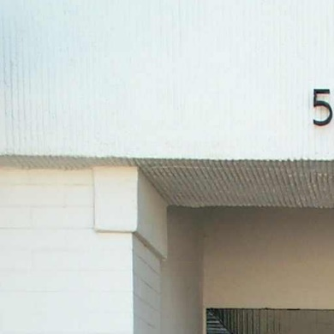 | 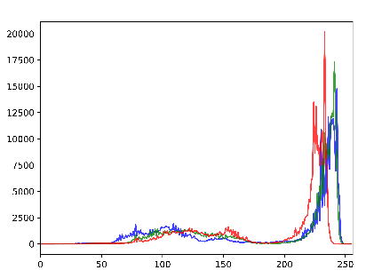 | Image 103  PSNR (In Message 10)  Proposed Method: 50.33 dB  Previous Method 1: 41.70 dB  Previous Method 2: 43.45 dB
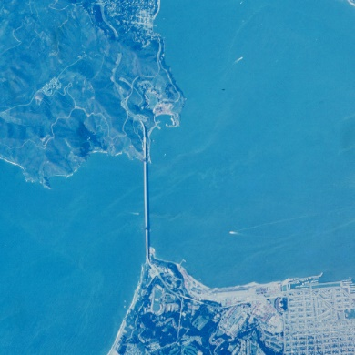 | 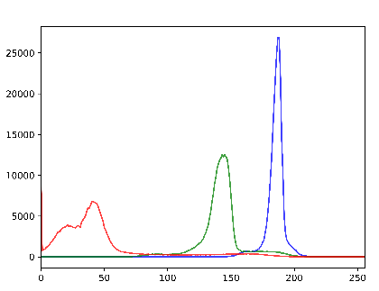 | Image 17  PSNR (In Message 10)  Proposed Method: 46.01 dB  Previous Method 1: 33.71 dB  Previous Method 2: 42.28 dB

Admittedly, the proposed method has a higher PSNR value than all tested methods. Figure 6 represented the image, where the proposed algorithm has the highest and lowest PSNR in the maximum payload. In the best case, the pattern of the histogram concentrated in a particular range. Furthermore, all of the channels have a similar trend, where this indicates the color used at the same rate. In the opposite case, the histogram seems to have a scattered pattern among the channels and has one dominant color. These two types of histogram model can use as an approach to get high value of PSNR, but it is not the only parameter that affects the PSNR. In fact, at the beginning of the proposed method, the selected channel is chosen by calculating the edge value, the second histogram in Figure 6 should work well, due to the optimization process at the beginning. The optimization channel process used to minimize the occurs of the Fall of Boundary Problem (FOBP) and not to optimize the PSNR.
All of the methods based on spatial domain steganography, wherein the technique embedded the message directly into the pixel value. It makes the hidden data cannot be extracted when the pixel has changed. So, all of the methods cannot resist cropping, zooming, compressing or any intentional distortion of the communication channel.

[1] Provos, Niels, and Peter Honeyman. "Hide and seek: An introduction to steganography." IEEE security & privacy 1.3 (2003): 32-44.
[2] Kharrazi, M., Sencar, H., T., Memon, N., 2004, Image Steganography: Concepts and Practice, lecture notes, Institute for Mathematical Sciences, National University of Singapore, delivered 22 April 2004.
[3] Subhedar, M. S., & Mankar, V. H. (2014). Current status and key issues in image steganography: A survey. Computer science review, 13, 95-113.
[4] Wu, D. C., & Tsai, W. H. (2003). A steganographic method for images by pixel-value differencing. Pattern Recognition Letters, 24(9-10), 1613-1626.
[5] Swain, G. (2018). High capacity image steganography using modified LSB substitution and PVD against pixel difference histogram analysis. Security and Communication Networks, 2018.
[6] Saleh, M. E., Aly, A. A., & Omara, F. A. (2015). Enhancing pixel value difference (PVD) image steganography by using mobile phone keypad (MPK) coding. International Journal of Computer Science and Security (IJCSS), 9(2), 397-397.
[7] Ker, A. D. (2005, June). A general framework for structural steganalysis of LSB replacement. In International Workshop on Information Hiding (pp. 296-311). Springer, Berlin, Heidelberg.
[8] MSLDIP

